CALL FOR SUBMISSIONS:
Community engagement for inclusive rural transformation and gender equality
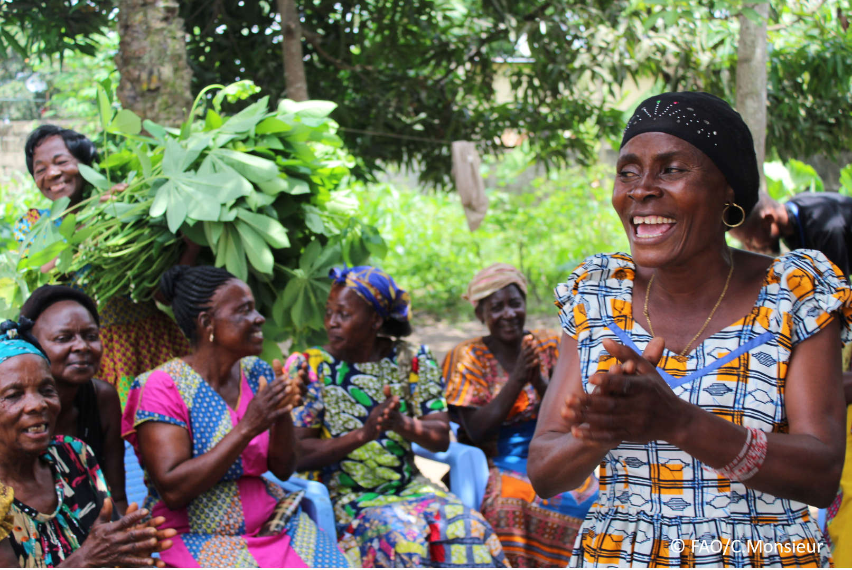
The objective of this call for submissions is to collect good practices, experiences, and lessons learnt on the use of community engagement for inclusive rural transformation and gender equality. The initiative, organized by the Rural Transformation and Gender Equality Division (ESP), seeks to gather insights from a diverse range of contributors, both within FAO and from external stakeholders. Its goal is to share knowledge, foster learning, and guide the scaling up of community engagement and community-led collective action to leave no one behind. The call builds on FAO's past efforts in this area, such as the Community Engagement Days series of webinars.
The call for submissions is open until 27 November 2024.

How to take part in this call for submissions:
To take part in this Call for submissions, please register to the FSN Forum, if you are not yet a member, or “sign in” to your account. Please review the topic note to understand the criteria we are considering for this call. If you wish to learn more about community engagement, you may refer to the background document. Once you have completed this submission template, upload it in the box “Post your contribution” on the call webpage, or, alternatively, send it to fsn-moderator@fao.org.
Please keep the length of submissions limited to 1,500 words and feel also free to attach relevant supporting materials.

Template for submissions

Contact person | Name: AUGUSTUS OSEI ASARE  Organization/Unit: INTERNATIONAL LABOUR ORGANIZATION/EIIP  Country: PAPUA NEW GUINEA  Email address: asare@ilo.org  augustuskoasare@gmail.com
Name/title of the good practice | Better transport infrastructure and decent jobs in rural areas: The impact of employment-intensive investments on inclusive transformation and gender equality.
Where is the good practice taking place? (Multiple selection allowed) | ☐ Europe and Central Asia  ☐ Latin America and the Caribbean  ☐ North Africa and Near East  ☐ Sub-Saharan Africa  ☒ Asia and the Pacific  ☐ North America  ☐ Global
Affiliation | ☐ Farmer and producer organizations  ☐ Trade Union  ☐ Informal community-based, farmer-based or self-help group  ☐ Research and academia  ☐ Government  ☐ Local/traditional authorities  ☐ Private Sector  ☐ Civil Society Organization  ☒ Intergovernmental Organization (e.g. UN system, World Bank)  ☐ Resource Partner/Donor  ☐ Other (please specify)
In which sector(s) and context (s) have you used this community engagement good practice? (Multiple selections allowed) | ☐ Education  ☐ Health and Sanitation  ☐ Food production in agrifood systems (please also tick the sub-categories)  ☐ Crop cultivation  ☐ Fisheries and aquaculture production  ☐ Livestock  ☐ Forestry  ☐ Agroforestry  ☐ Horticulture  ☐ Apiculture (beekeeping)  ☐ Agroecology and sustainable farming practices  ☐ Soil and water management  ☐ Other:  ☐ Post-production in agrifood systems (please also tick the sub-categories)  ☐ Processing and value addition  ☐ Marketing and retailing  ☐ Transporting  ☐ Food loss and waste  ☐ Packaging  ☐ Storage  ☐ Distribution  ☒ Other: Transport Infrastructure Enabler to Cocoa, Vanilla and Fisheries value chains.  ☒ Gender Equality  ☒ Climate Action  ☐ Citizenship and Governance  ☐ Social Protection  ☐ Humanitarian and protracted crisis  ☐ Conflict resolution, peace and resilience  ☐ Digital innovation  ☐ Other sector (please specify) _________
Who are the financial partners supporting this good practice, if applicable? | European Union (EU)
- In a few sentences, summarize your community engagement good practice.
Demonstrating how the employment-intensive investment approach leverages local resources and community engagement to enhance transport infrastructure and create decent jobs in rural areas.
- What problem(s) or challenge(s) does your good practice aim to address through community engagement?
The agriculture sector is a key source of employment in many Pacific Island countries, including Papua New Guinea. However, farmers, including women, face challenges in accessing markets due to poor transport infrastructure. Enhancing access through local resources, such as community engagement and employment-intensive investment technology, creates decent employment opportunities for the poor and vulnerable, including women and youth. Also, rehabilitating and maintaining transport infrastructure, acts as enabler of the value chains such as cocoa, vanilla and fishery, which are important drivers of economic growth in the country.
- Describe your good practice in more detail. Include the main guiding principles, the desired changes or outcomes you aim to achieve (Theory of Change), and the key phases of implementation.
Enhancing transport infrastructure through rehabilitation and maintenance works using local resource-based approaches can significantly improve living standards by directly impacting the quality of lives in rural communities. Improved and well-maintained local transport infrastructure not only leads to poverty reduction but also unlocks substantial potential economic and social opportunities. Employment-intensive investments link infrastructure development with the creation of decent employment, poverty reduction and the broader goals of local economic and social development. By utilizing local community labour and resources, these initiatives generate much-needed employment and income, reduce costs, save foreign currency, and bolster local industries. Furthermore, they enhance the capacity of local institutions, ensuring sustainable development and long-term resilience.

- Who are the key actors and stakeholders involved in the design and implementation of the good practice, and what are their respective roles? Consider local partners, government, local authorities, community radios, civil society, research, the private sector, etc.
The main project stakeholders, are Department of National Planning and Monitoring (DNPM), FAO, ITU, UNCDF, UNDP and the ILO. The table below further provides the roles and responsibilities of the partners as well as that for other participating institutions to the programme:
Partner | Roles and Responsibilities
DNPM | - Oversee overall STREIT Programme implementation  - Co- Chairs the Technical and Programme Steering Committee (PSC) meetings  - Liaises with Development Partners and Donors.  - Assist in establishing an effective monitoring and evaluation system for the programme  - Act as a liaison between all spheres of government and the private sector regarding STREIT Programme implementation
United Nations Agencies | International Labour Organization (ILO)  - Implementing the transport infrastructure component of STREIT Programme (rural roads, airstrips and waterway clearance) that provides access to cocoa, vanilla and fisheries value chains as well as access to social services like education, clinics/hospitals, training and capacity development of government and private sector (contractors), and communities in the implementation of transport infrastructure through the application of local resource-based and employment intensive approaches.  Food and Agrricultural Organization (FAO)  - Providing value chain enhancement to cocoa, vanilla, and fisheries to maximize economic returns.  International Telecommunications Union (ITU)  - Enabling Information and communications technology (ICT) and Marketing access to cocoa, vanilla and fisheries value chains as well as to the rural communities.  United Nations Capital |Development Fund (UNCDF)  - Offers digital financial services as enablers to cocoa, vanilla and fisheries value chains as well as to the rural communities.  UNITED NATIONS DEVELOPMENT PROGRAMME (UNDP)  - Provides renewable energy solutions as enablers to cocoa, vanilla and fisheries value chains as well as to the rural community schools and clinics
University of Technology (UNITECH) and TVET Institutions | - Appoint trainers and training service providers  - Provide accredited skills training  - Monitor skills training.
Government Implementing Bodies | - Support ILO in identifying suitable transport infrastructure projects for implementation  - Support in community engagements and conflict resolutions.  - Participate in training delivery  - Ensuring ownership and sustainability by taking over and providing adequate annual budgets for improved infrastructure implementation and maintenance.
Private Sector:  - Local Contractors | - Carry out construction and maintenance of works  - Provide on-site quality control
Non-Profit Organizations: Rural Airstrips Agency (RAA) | - Collaborates with ILO in identifying, planning and implementing community-based airstrips rehabilitation and maintenance projects.  - Community mobilization and liaison
Rural Communities | - Provide workforce  - Participate in project-level Project Steering Committee meetings  - Provide access to the use of local resources.

- How does your intervention ensure inclusivity and equal and meaningful participation within the community?
Describe how your intervention includes and engages different groups within the community. Consider aspects like gender, age, ethnicity, disability status, livelihoods, and other specific conditions (e.g., people living in prolonged crisis, migrants, refugees). Explain how your intervention engages diverse segments of the rural community. Highlight the specific actions or strategies you use to reach these groups. If applicable, mention if your intervention uses specific approaches such as gender-responsive, gender-transformative, intersectionality, or other methods to ensure inclusivity and gender equality.
Gender and youth inclusivity in the ILO transport infrastructure component is achieved through:
- Gender and Youth Quotas: Setting minimum participation targets (e.g., 30%) for women and youth across all project stages.
- Flexible Working Hours: Implementing task-based remuneration systems, allowing participants to balance work with household or farming duties.
- Part-time Opportunities: Encouraging participation through part-time work arrangements.
- Equal Pay: Ensuring women and youth receive equal pay for equal work.
- Childcare Facilities: Providing on-site childcare (e.g., crèches) to support nursing women.
- Advocacy Campaigns: Using tools like publications, videos, social media, and events to promote women and youth participation.
Recognition of Excellence: Annual awards celebrate and reward outstanding contributions by women and youth in project implementation.
- By using community engagement, what results and impacts have your good practice achieved?
Please provide specific examples and evidence demonstrating the effectiveness of your intervention, focusing on both qualitative and quantitative outcomes related to livelihoods and well-being improvements.
The ILO promotes employment-intensive approaches in local infrastructure development across Pacific countries. In Papua New Guinea’s East and West Sepik Provinces, the ILO collaborates on the EU-funded STREIT programme to improve rural transport infrastructure, enhance cocoa, vanilla, and fisheries value chains, and foster rural development through sustainable, climate-resilient actions.
With a budget of $22.3 million, the programme focuses on:
- Rural Roads: Rehabilitating 205 km and maintaining 312 km.
- Airstrips and Waterways: Rehabilitating five airstrips and clearing 215 km of waterways.
- Training: Over 1,200 stakeholders trained, including government and private actors.
- Key outcomes include improved market access, healthcare, and education; reduced travel times by up to 83%; $4 million injected into local economies; 390,000 decent workdays created; enhanced skills and employability; and advanced infrastructure planning systems, such as the Road Transport Information Management System (RoTIMS).
- Among these results, has the good practice led to improvements in terms of gender equality, women’s empowerment, and/or social inclusion?
Describe the behavioral changes in terms of gender that the good practice promotes, emphasizing agency, leadership, and participation in local governance. Include efforts to challenge discriminatory norms and unequal power dynamics. Highlight also how the intervention has supported the well-being (including psychological resilience) of marginalized groups and enhanced their inclusion and participation in decision-making processes.

Women and youth participation as well as employment and income earned are 51% and 34%, respectively.
What key challenges did you encounter while implementing the community engagement activities, and how did you address them?
Include any resistance from communities, pushback, or issues related to unequal power dynamics, if applicable.
Challenges | Mitigation Measures
Non-availability of Construction materials – e.g. pipe culverts, gabion boxes are only available in the big cities. The only means of transportation is by ship which requires bulk purchases, long delivery times and involve significant advance payments. | Changes in designs - relying on locally available materials e.g. slab culverts instead of imported concrete pipes.
Changes in rain patterns. There are basically two seasons in the country - dry and wet seasons. In the Sepik region, the wet season is normally from October to January but in recent yeas, wet season lasted until May. Unusual inclement weather affected the physical works progress. | Reviewing contracts and providing appropriate no-cost contract extensions of time.
Unexpected nationwide shortage of fuel supply - halted transportation activities. Similarly, due to frequent electricity power cut-offs by PNG power, this also affected the fuel supply to contractors. | Providing appropriate no-cost contract extensions of time.
Community violence and vandalism of contractors’ equipment – hostile environment disrupted road rehabilitation works - 6 out of 11 sites halted. Regarded as unforeseen security risks. | Contractors have been advised to engage professional security firms. The incurred invoices/claims are reimbursed by ILO.
Contractors’ Cashflow - The contractors were not given advance payment towards mobilization and procurement of materials due to their inability to secure the required bank guarantees. | ILO is directly paying contractors’ material suppliers and deducting amounts from contractors’ interim payments.

- What are the key lesson learned from your community engagement good practice?
- Local resource-based, employment-intensive methods create jobs, boost incomes, and improve vulnerable communities' livelihoods.
- Community Maintenance Groups ensure timely rural road upkeep, enhancing climate resilience and infrastructure lifespan.
- Environmental surveys before construction identify risks and mitigate negative impacts.
- Climate-adaptive designs address rainfall and flooding but require adequate investment.
- Using local materials reduces reliance on urban centers, speeds delivery, and stimulates the local economy.
- Stakeholder consultations and community engagement address risks, resolve challenges, and ensure smooth implementation.
- Has this practice been replicated in the same context or in different contexts?
What are the required conditions to replicate and adapt the practice in another context/geographical area?
The ILO’s local resource-based approaches have been successfully applied in Pacific Island nations like Vanuatu and the Solomon Islands, addressing limited transport infrastructure and job creation needs in rural areas.
Key Conditions for Replication and Adaptation:
- Contextual Tailoring: Assess and adapt the model to specific local needs and conditions.
- Local Resources: Use local labor, skills, and materials to enhance efficiency, reliability, and timely delivery.
- Capacity Building: Strengthen local institutions and communities to ensure project sustainability.
- Addressing Challenges: Tackle issues like long supply chains and limited capacity through employment-intensive methods.
- Climate Adaptation: Integrate climate-proofing into projects to enhance resilience and livelihoods.
- Stakeholder Collaboration: Ensure strong government support, community engagement, and donor collaboration.
The ILO’s Employment-Intensive Investment Programme (EIIP) supports job creation and rural growth, with potential for scalable, sustainable solutions through tailored adaptation.

- How sustainable are the results achieved by this good practice?
Describe the key elements that need to be in place to make the initiative sustainable, including enabling environment (legal and policy frameworks and institutions), local ownership, accountability, etc.
Training and Capacity Development:
The ILO, in partnership with PNG University of Technology (PNG-UNITECH) and TVET institutions, developed curricula and materials to train 380 government officials, private sector staff, and community members in rural transport infrastructure management. The partnership ensures long-term ownership and sustainability by integrating these curricula into university and TVET programs, forming part of ILO's exit strategy.
Road Maintenance Management:
ILO-STREIT employs community Road Maintenance Groups (RMGs) for routine rural road maintenance, fostering community ownership, employment, and economic benefits while extending road lifespan. To sustain this strategy post-ILO, the National Department of Works and Highways (NDoWH) and local governments are supported in adopting this model, incorporating it into 5-year Road Transport Master Plans with allocated budgets.
Road Rehabilitation Management:
ILO uses local resource-based approaches for rural road rehabilitation and trains staff in planning, design, contract management, and safeguards. Sustainability relies on government staff mentorship and integration of six trained national engineers into provincial and district administrations after ILO’s exit.
Partnership with Rural Airstrips Agency (RAA):
Collaborating with RAA, ILO supports rural airstrip rehabilitation and maintenance while training provincial and local governments to ensure continuity after program completion.
Handover of Systems:
ILO developed a Road Transport Information Management System (RoTIMS) for NDoWH, aiding road prioritization and planning. Updated specifications, norms, manuals, and guidelines will be handed over to ensure sustainable transport infrastructure management post-ILO-STREIT.
- Based on the conversations FAO held during the Community Engagement days, a definition of community engagement for empowerment was proposed:

“Community engagement for empowerment and community-led collective action can be defined as an inclusive and participatory process that enables community members to become active agents of change in decisions affecting their lives, health, and environment. This process develops their capacity to achieve sustainable outcomes for improved rural livelihoods. Embracing a rights-based approach, it prioritizes the agency and participation of all community members, regardless of gender identity, sexual orientation, age, ethnicity, caste, socioeconomic status, political affiliation, migration status, or ability/disability. Indeed, inclusive approaches recognize the complexities of overlapping marginalization and discrimination that can exclude different community members from decision-making processes and implement strategies to foster their participation, agency and empowerment.”

We invite you to contribute to this definition. What would you add or change? Please share your thoughts, suggestions, and any additional elements you believe are crucial for a comprehensive understanding of community engagement approaches aimed at community-led collective action for inclusive rural transformation, people’s empowerment and gender equality.

- Commitment to Adaptive and Collaborative Governance
Community engagement should involve collaborative governance structures that adapt to evolving community needs and contexts.
Suggested Addition:
"This approach fosters adaptive and collaborative governance frameworks, ensuring that decision-making processes are flexible, transparent, and continually responsive to community needs and priorities."
- Highlight of Learning and Capacity Building
Empowerment relies heavily on continuous education and skill-building, both for community members and facilitators.
Suggested Addition:
"It emphasizes continuous capacity-building, fostering both individual and collective learning to strengthen community resilience and autonomy."
- Recognition of Environmental Stewardship
Given the focus on rural livelihoods and sustainability, the definition could more strongly emphasize environmental stewardship and the community's role in ecosystem management.
Suggested Addition:
"In addition, it encourages environmental stewardship, recognizing the community’s critical role in managing and preserving local ecosystems for future generations."
- Based on your experience, what gaps or areas for improvement still need to be addressed in the field of community engagement?
Suggested Improvements for Enhancing Community Engagement:
- Address root causes of inequality, ensuring engagement doesn’t replicate power imbalances.
- Include communities in participatory monitoring, evaluation, and outcome adjustments.
- Update practices to tackle emerging vulnerabilities and evolving conditions.
- Foster co-leadership models where communities share decision-making power.
- Provide funding, capacity-building, and technology access to sustain initiatives.
- Build trust through transparency and platforms for marginalized voices.
- Tailor engagement strategies to each community’s socio-cultural and environmental context.
- Integrate expertise across sectors, linking conservation, livelihoods, and health.
- Use digital tools to expand participation and prepare for global challenges.
- What do you think is FAO's role in the field of community engagement? How can FAO support and enhance interventions like yours, if applicable? Consider aspects such as policy advocacy, capacity development, funding, technical assistance, knowledge production and sharing, and fostering partnerships.
FAO’s support to enhance agricultural value chains and economic returns should be linked to enablers such as transport infrastructure development which will ensure access to markets and other social services.
Link(s) to specific references about your good practice (e.g. reports, communication products, videos, articles)  https://www.ilo.org/resource/news/paving-future-how-yawasoro-niewanjie-road-rejuvenates-lives-and-livelihoods  https://www.youtube.com/watch?v=uTr-wQbXurU&list=PL8itJ-8CfpcwIAz_0uzXwrxxsJVKir3S3&index=2 | Please include attachment(s) or add here link(s) to documents/videos/podcasts/other with specific references.

The call for submissions is directly aligned with the thematic components of collective action within FAO's Programme Priority Areas (PPAs), specifically Better Life 1 (Gender Equality and Rural Women’s Empowerment), Better Life 2 (Inclusive Rural Transformation) and Better Life 3 (Agriculture and Food Emergencies).

